Monolithic Architecture

Deploy WordPress and MYSQL on the same instances

Step 1. Log in to AWS account

Step 2. Launce Ubuntu Instance

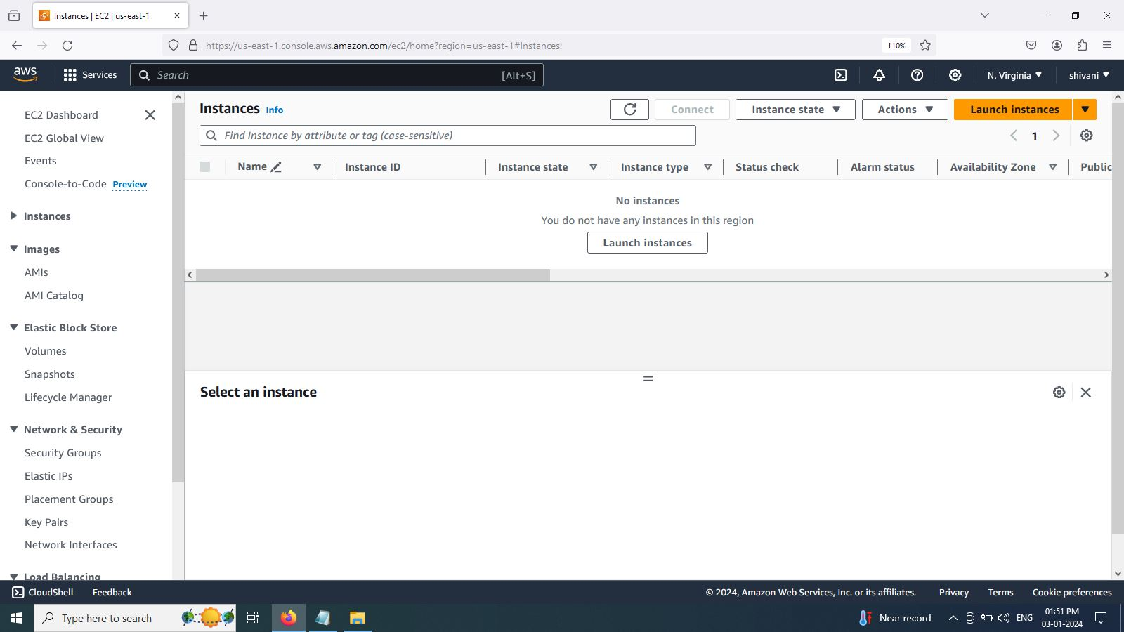

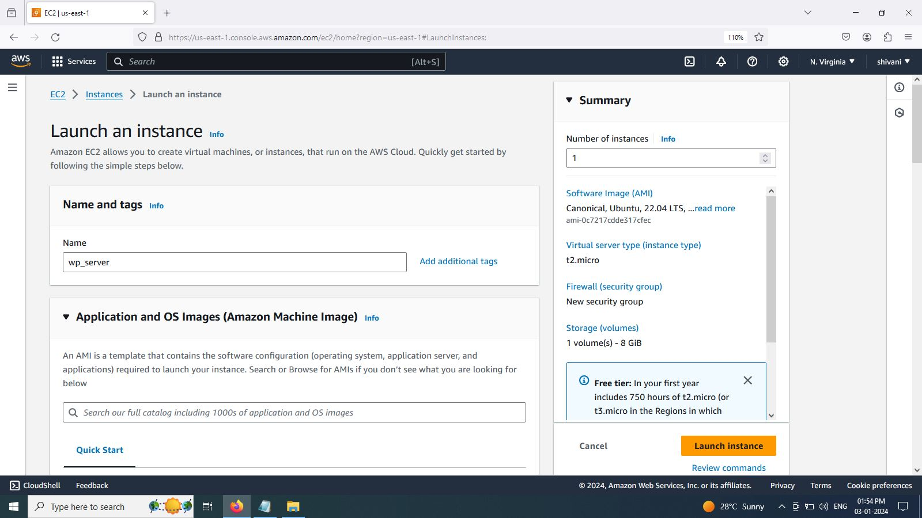

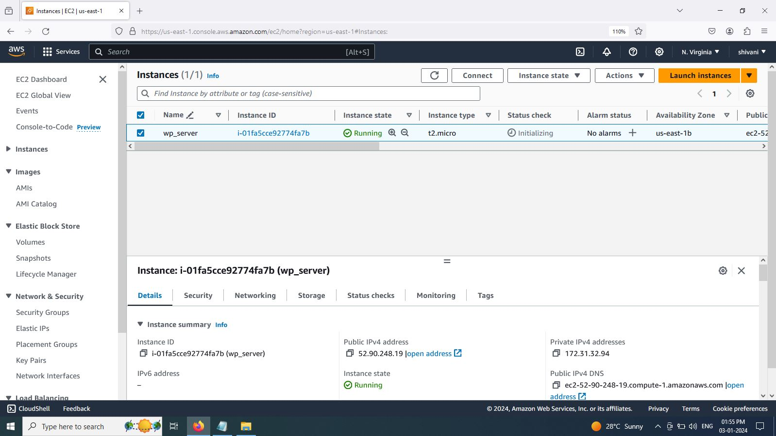

Step 3. Connect to Instance using MobaXterm

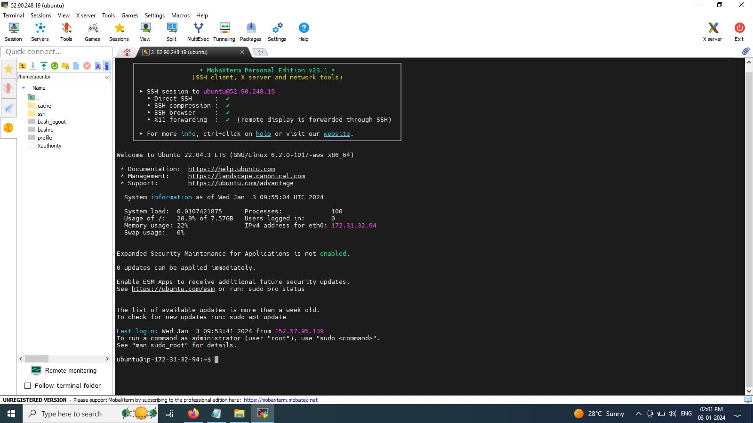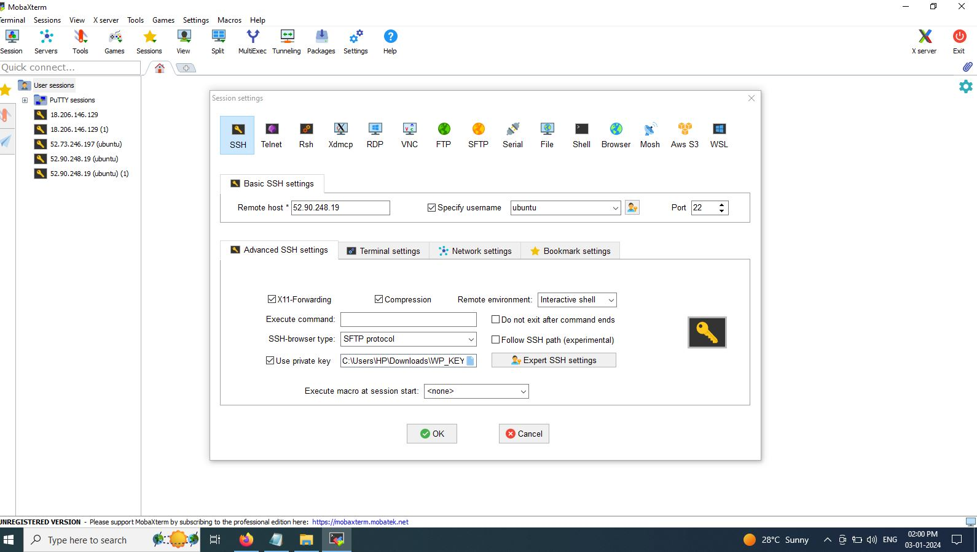

Step 4. Install Apache server on Ubuntu

Command: sudo apt install apache2

Step 5. Install php runtime and php mysql connector

Command: sudo apt install php libapache2-mod-php php-mysql

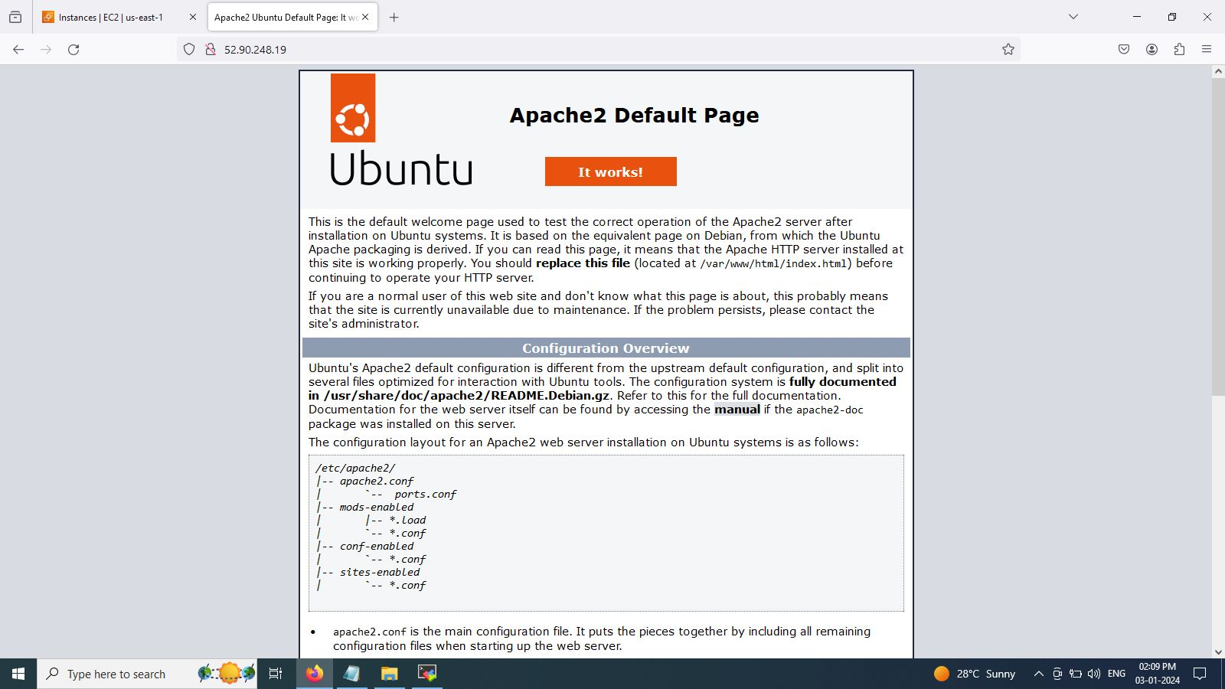

Step 6. Install MySQL server

Command: sudo apt install mysql-server

Step 7. Login to MySQL server

Command: sudo mysql -u root

Step 8. Change authentication plugin to mysql_native_password

Command: ALTER USER 'root'@'localhost' IDENTIFIED WITH mysql_native_password by 'Sohan@512';

Step 9. Create a new database user for wordpress

Command: CREATE USER 'wp_user'@localhost IDENTIFIED BY 'Sohan@512';

Step 10. Create a database for wordpress

Command: CREATE DATABASE wp;

Step 11. Grant all privilges on the database 'wp' to the newly created user

Command: GRANT ALL PRIVILEGES ON wp.* TO 'wp_user'@localhost;

Step 12. Download wordpress

Command: cd /tmp

Command: wget <https://wordpress.org/latest.tar.gz>

Step 13. Unzip file

Command: tar -xvf latest.tar.gz

Step 14. Move wordpress folder to apache document root

Command: sudo mv wordpress/ /var/www/html

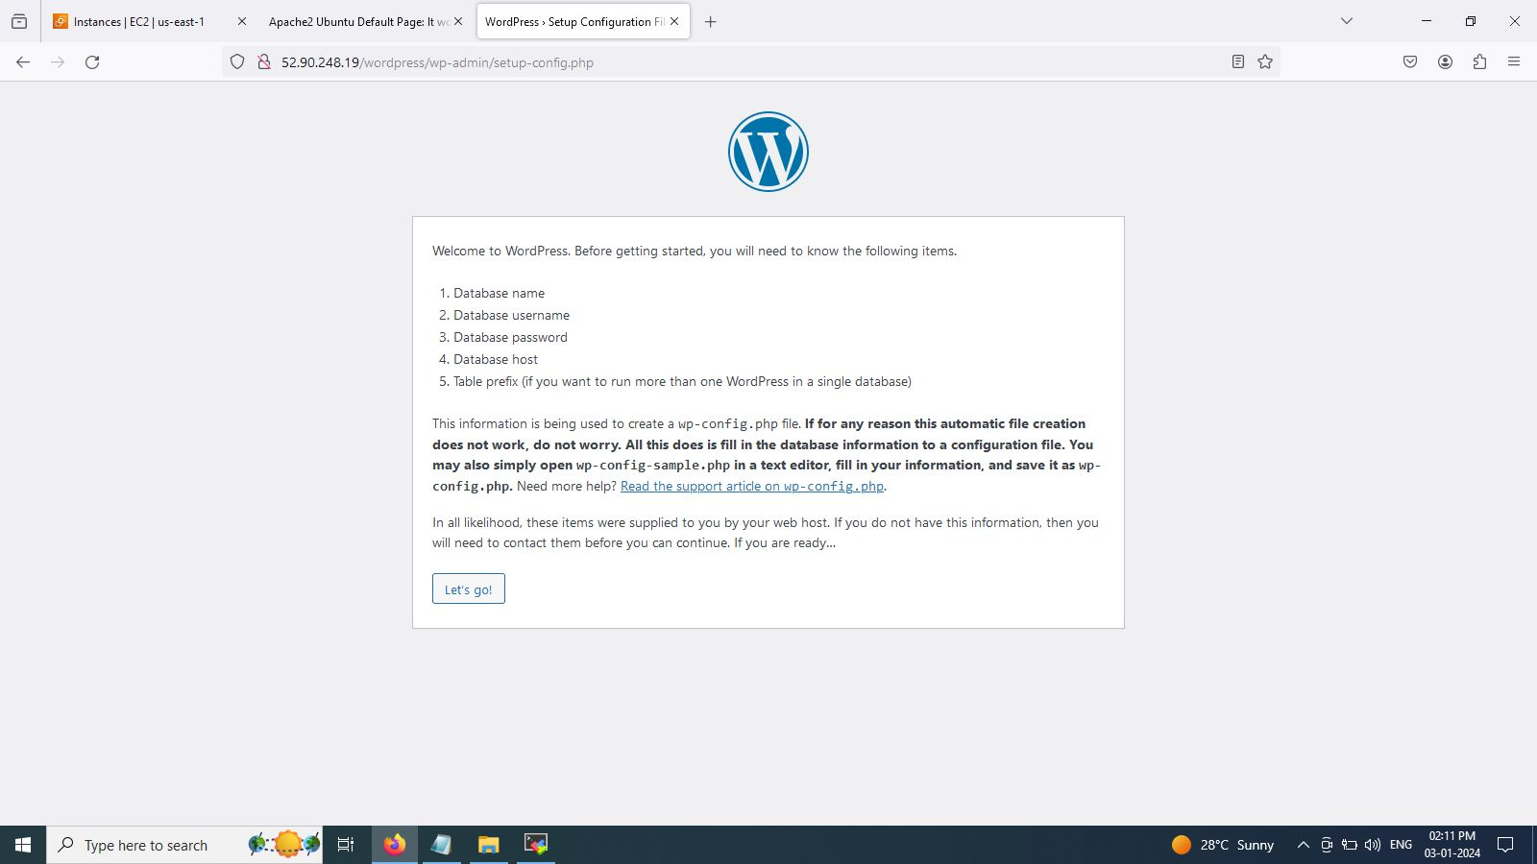

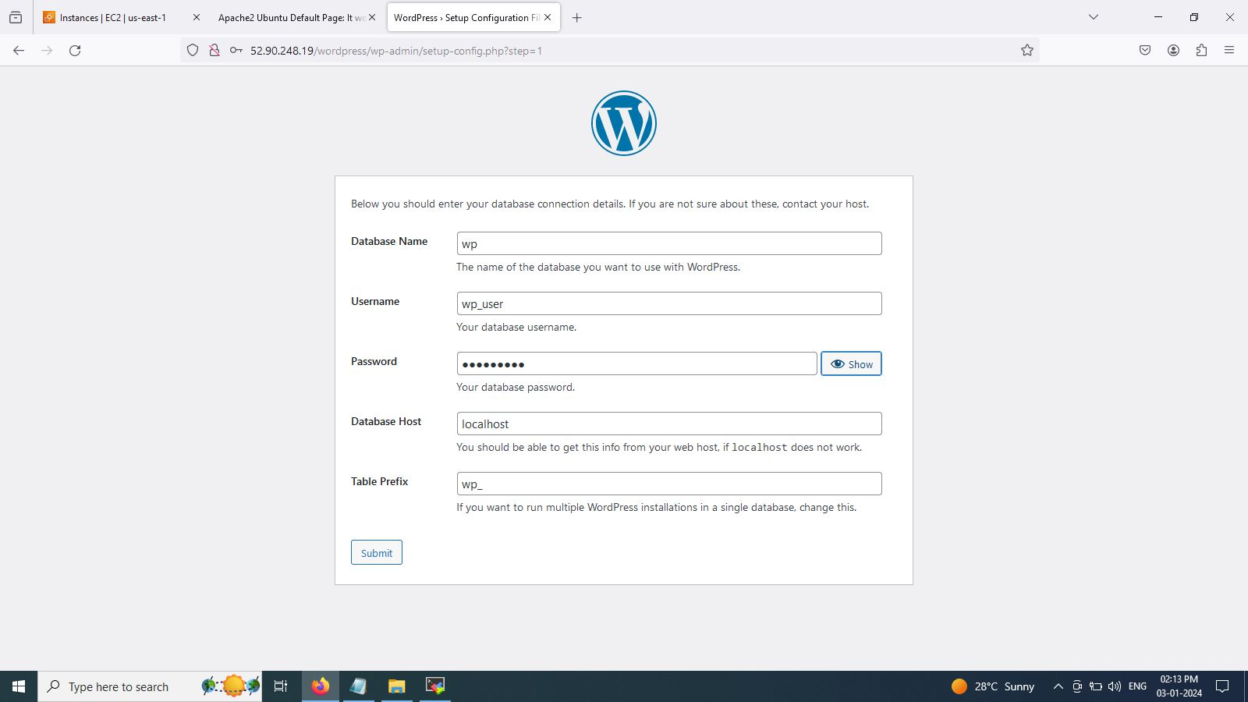

Step 15. cd /var/www/html

cd wordpress/

vim wp-config.php (Copy php code to wp-config.php )

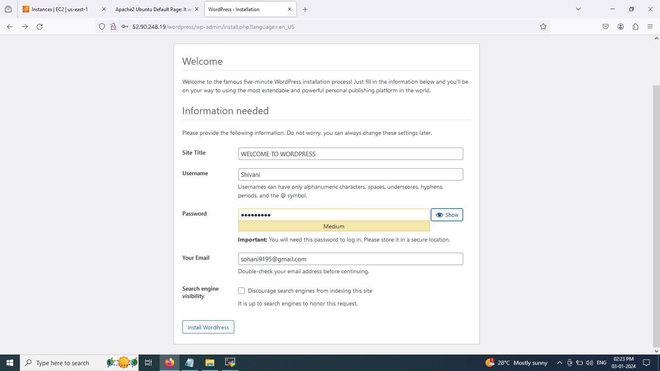

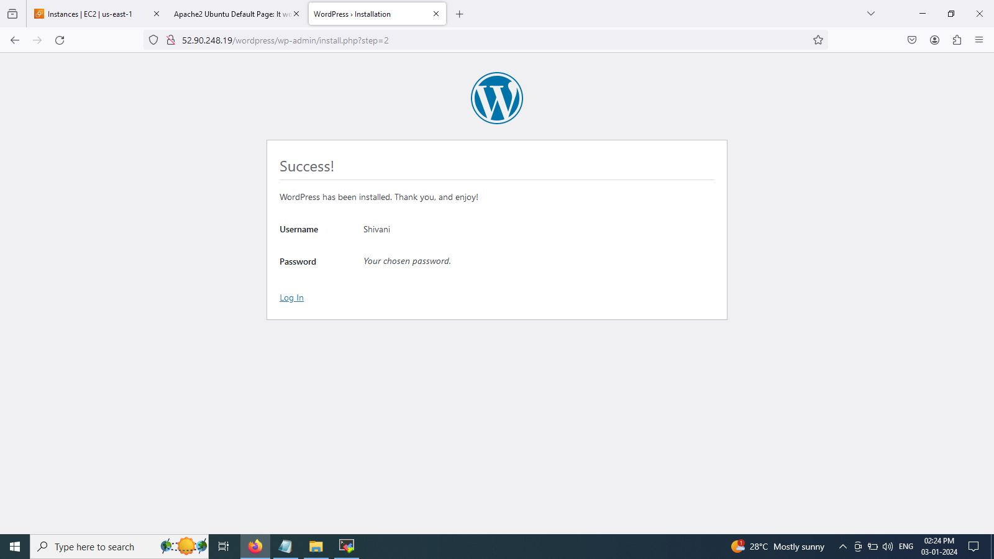

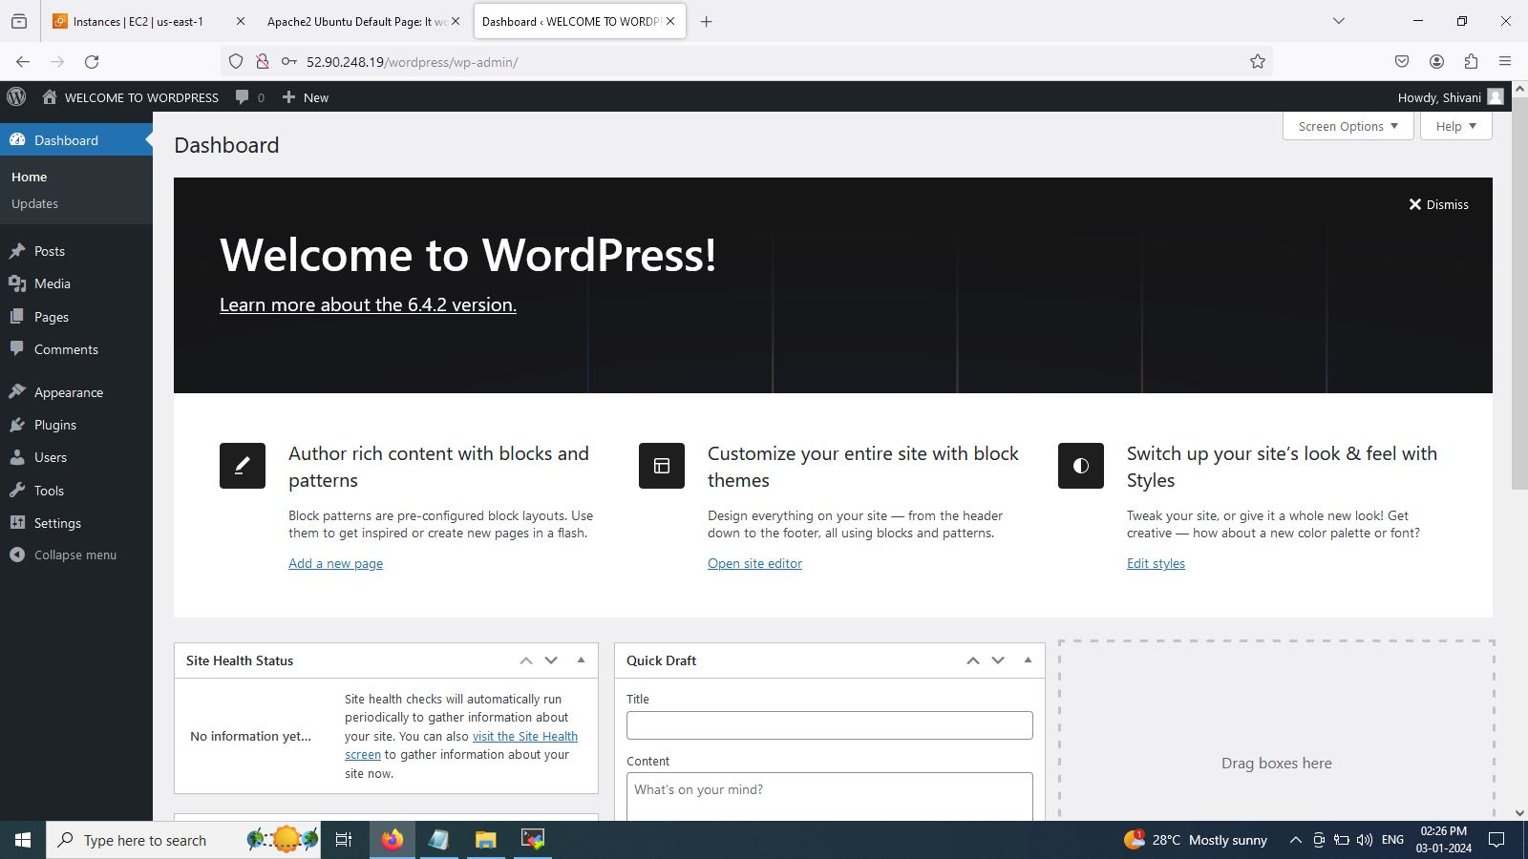

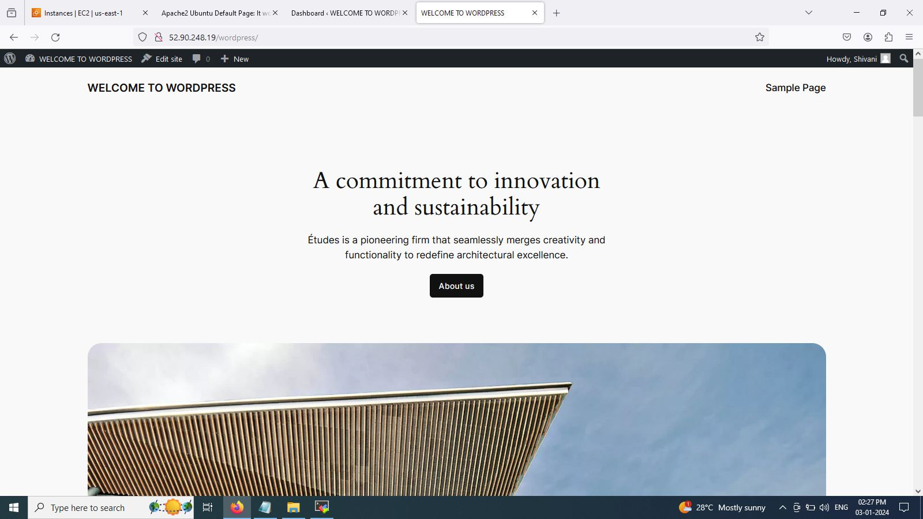

Step 16 . command : cd /etc/apache2/sites-available/

sudo vim 000-default.conf

edit : DocumentRoot /var/www/html/wordpress

Step 17. Restart/reload apache server

Command : sudo systemctl restart apache2

